COURSE: DSA0406 - Fundamentals of Data Science Name: Siva Balan K
DATE: 06.10.2026 Reg.no: 192572037

EXPERIMENT 1: How would you use NumPy arrays to calculate the average score for each subject and determine the subject with the highest average score? Assume 4x4 matrix that stores marks of each student in given order.

Aim
To calculate the average mark for each subject using NumPy and identify the subject with the highest average mark.

Program
import numpy as np

# Rows represent students; columns: Math, Science, English, History
student_scores = np.array([
[85, 78, 92, 74],
[90, 88, 85, 80],
[76, 82, 89, 91],
[95, 91, 94, 86]
])

subjects = np.array(["Math", "Science", "English", "History"])
averages = np.mean(student_scores, axis=0)
highest_index = np.argmax(averages)

print("Average score for each subject:")
for subject, average in zip(subjects, averages):
print(f"{subject}: {average:.2f}")
print(f"Highest average: {subjects[highest_index]} ({averages[highest_index]:.2f})")

Output
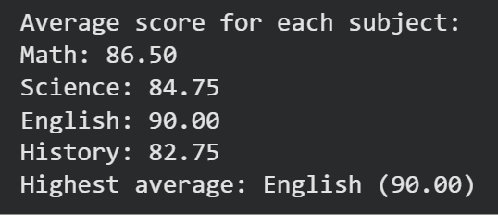

Result
The average score for each subject was calculated using NumPy, and the subject with the highest average score was identified.

EXPERIMENT 2: How would you find the average price of all the products sold in the past month? Assume 3x3 matrix with each row representing the sales for a different product

Aim
To calculate the average price of products sold using a NumPy array.

Program
import numpy as np

# Each row represents a product; values are recorded sale prices
sales_data = np.array([
[120.00, 125.00, 118.00],
[75.00, 80.00, 78.00],
[200.00, 190.00, 210.00]
])

average_price = np.mean(sales_data)
print(f"Average price of all products sold: ${average_price:.2f}")

Output

Result
The mean of all recorded prices was calculated to obtain the average product price.

EXPERIMENT 3: Using NumPy arrays and operations, how would you find the average sale price of houses with more than four bedrooms in the neighborhood?

Aim
To select houses with more than four bedrooms and calculate their average sale price using NumPy.

Program
import numpy as np

# CSV columns: bedrooms, square footage, sale price
house_data = np.genfromtxt("houses.csv", delimiter=",", skip_header=1)

more_than_four_bedrooms = house_data[:, 0] > 4
matching_prices = house_data[more_than_four_bedrooms, 2]

if matching_prices.size > 0:
average_price = np.mean(matching_prices)
print(f"Average sale price (>4 bedrooms): ${average_price:,.2f}")
else:
print("No houses with more than four bedrooms were found.")

Output

Result
The average sale price was calculated for houses having more than four bedrooms.

EXPERIMENT 4: Using NumPy arrays and arithmetic operations calculate the total sales for the year and determine the percentage increase in sales from the first quarter to the fourth quarter?

Aim
To calculate total sales for four quarters and the percentage increase from the first quarter to the fourth quarter.

Program
import numpy as np

sales_data = np.array([125000, 138000, 147500, 162000], dtype=float)

total_sales = np.sum(sales_data)
percentage_increase = ((sales_data[3] - sales_data[0]) / sales_data[0]) * 100

print(f"Total sales for the year: ${total_sales:,.2f}")
print(f"Increase from Q1 to Q4: {percentage_increase:.2f}%")

Output
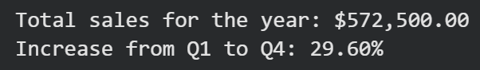

Result
The total sales for the year and the percentage increase from the first quarter to the fourth quarter were calculated.

EXPERIMENT 5: How would you use NumPy arrays and arithmetic operations to calculate the average fuel efficiency and determine the percentage improvement in fuel efficiency between two car models?

Aim
To calculate the average fuel efficiency of car models and the percentage improvement between two selected models.

Program
import numpy as np

fuel_efficiency = np.array([28.5, 31.0, 35.5, 40.0, 33.0])
average_efficiency = np.mean(fuel_efficiency)

# Compare model 1 (index 0) with model 2 (index 1)
old_model = fuel_efficiency[0]
new_model = fuel_efficiency[1]
percentage_improvement = ((new_model - old_model) / old_model) * 100

print(f"Average fuel efficiency: {average_efficiency:.2f} mpg")
print(f"Improvement from model 1 to model 2: {percentage_improvement:.2f}%")

Output
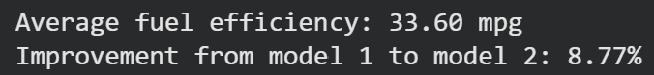

Result
The average fuel efficiency and the percentage improvement between the selected two models were calculated.

EXPERIMENT 6: Use arithmetic operations to calculate the total cost of a customer's purchase, including discounts and taxes, given the item prices, quantities, discount rate, and tax rate?

Aim
To calculate the total cost of a customer’s purchase after applying a discount and tax.

Program
item_prices = [2.50, 4.00, 3.25, 6.75]
quantities = [3, 2, 4, 1]
discount_rate = 10 # percent
tax_rate = 8 # percent

subtotal = sum(price * quantity
for price, quantity in zip(item_prices, quantities))
discount_amount = subtotal * (discount_rate / 100)
discounted_total = subtotal - discount_amount
tax_amount = discounted_total * (tax_rate / 100)
final_total = discounted_total + tax_amount

print(f"Subtotal: ${subtotal:.2f}")
print(f"Discount: ${discount_amount:.2f}")
print(f"Tax: ${tax_amount:.2f}")
print(f"Total cost: ${final_total:.2f}")

Output

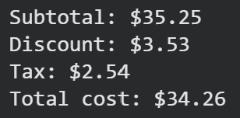

Result
The purchase total was calculated by applying the discount to the subtotal, then adding tax to the discounted amount.

Google Collab Link :- https://colab.research.google.com/drive/1DqkqJhg6sd1pxlHkt42eWLPRrHeu1rmo?usp=sharing

